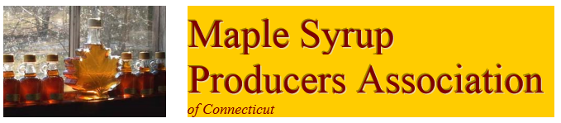
YOU ARE INVITED TO BECOME A MEMBER OF MSPAC TODAY!

WHO ARE WE? MSPAC, Inc. is a nonprofit organization of individuals bound together by their common interest in sugaring for fun and profit. The Association’s stated objective is to encourage the production and handling of high quality maple syrup products in Connecticut. This is done by providing a medium for mutual recognition and exchange of information among its members. Some members produce 1 gallon of syrup a year, others produce 100 or more, and still others are just interested.
WHAT DO WE DO? MSPAC, Inc. holds at least two informational meetings each year where speakers emphasize practical, “how-to-do-it” topics covering all aspects of sugaring. Free literature and lively discussion is always available. MSPAC, Inc. publishes a periodic newsletter for members including articles, timely
discussions and a free wanted to buy, sell or swap column. Included with your membership is a subscription to the “Maple Syrup Digest.” MSPAC, Inc. is a member of the North American Maple Syrup Council and participates in the activities of the International Maple Syrup Institute. The association also works closely with a number of other state agencies including the Connecticut Department of Agriculture, The University of Connecticut’s Cooperative Extension System and the Connecticut Agriculture Experiment Station in New Haven. MSPAC currently maintains an informative website at ctmaple.org and/or ctmaple.com.
HOW CAN WE ASSIST YOU? The Connecticut Maple Syrup Producers Manual, a publication containing production and quality control guidelines, is available to Members for reference and/or
distribution. Available for purchase are both an 8 inch by 12 inch or an 18 inch by 24 inch metal sign with the Association’s name and logo on them. Also available for purchase is a Maple Syrup Grading Poster, suitable for display in all Connecticut sugarhouses, that describes the current grading standards. **Items available for purchase are available only at MSPAC meetings**. Members wishing to market their product may, for a nominal fee, participate in MSPAC, Inc. annual brochure Guide to Connecticut Sugarhouses Open to the Public.
HOW DO I JOIN OR RENEW? To become a MSPAC, Inc. member, complete the form below and mail to the address noted with your annual dues of $40.00. If renewing, please complete the form to help keep records up to date.

